Read Me for Burmese Power Website

1. Clone all the files from git
2. Place all the Files your Laravel Folder

For me the location is: C:\xampp\htdocs\laravel\laravel\BurmesePower

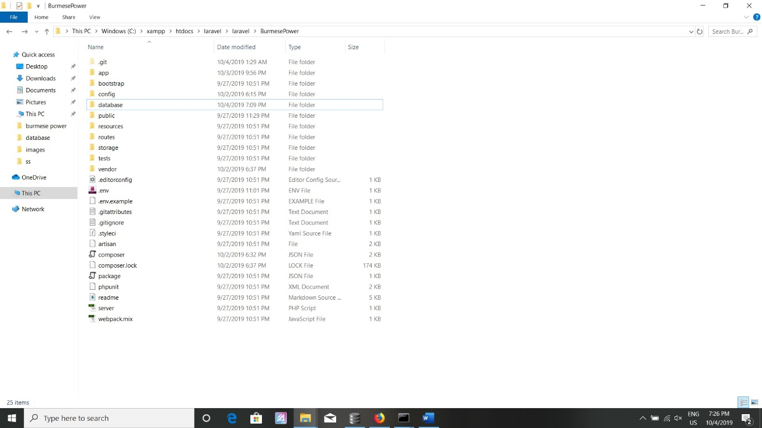

1. U need to attach database in this Laravel file

I use DB Browser for attach my database file

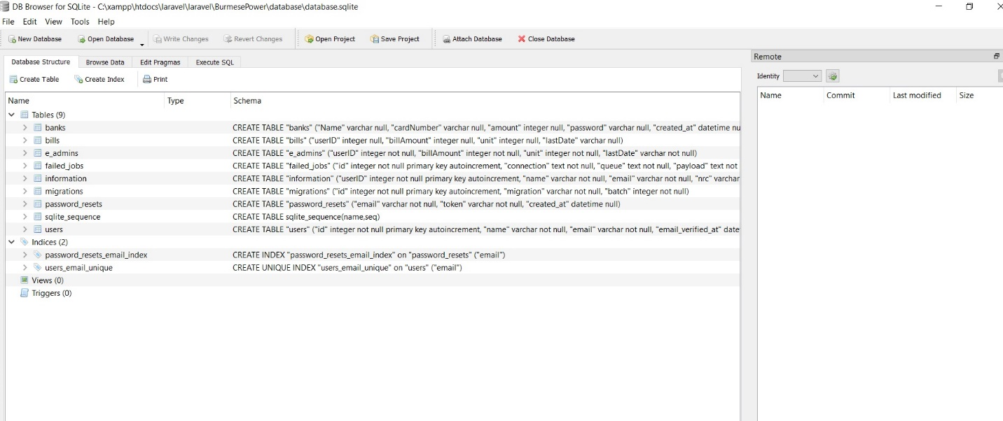

1. U need to start the Laravel Server

For this stage, you already installed Laravel Composer and its Package If u have no composer, see configuration guide from here: <https://laravel.com/docs/6.x>

After installing Composer, call command prompt start Laravel server

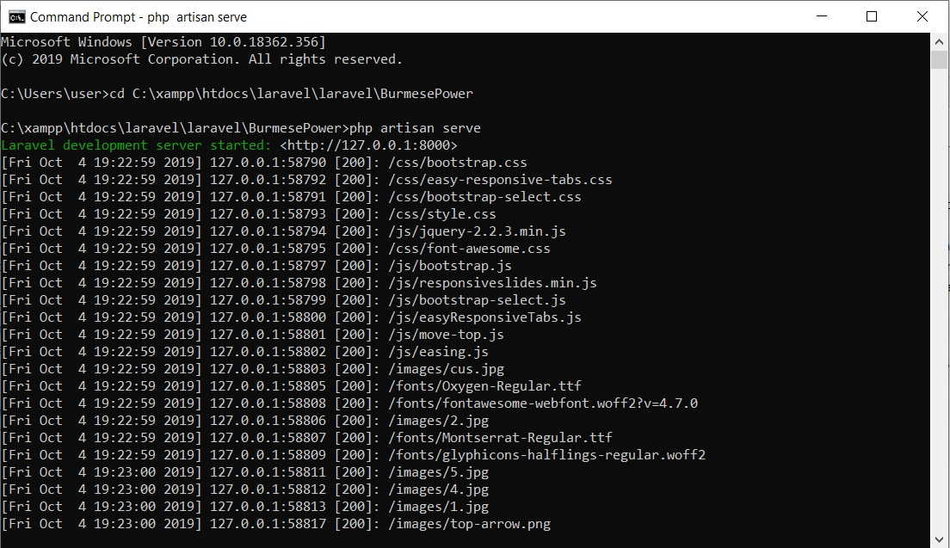

1. Copy the URL address from this command prompt and run in the browser and can the like this

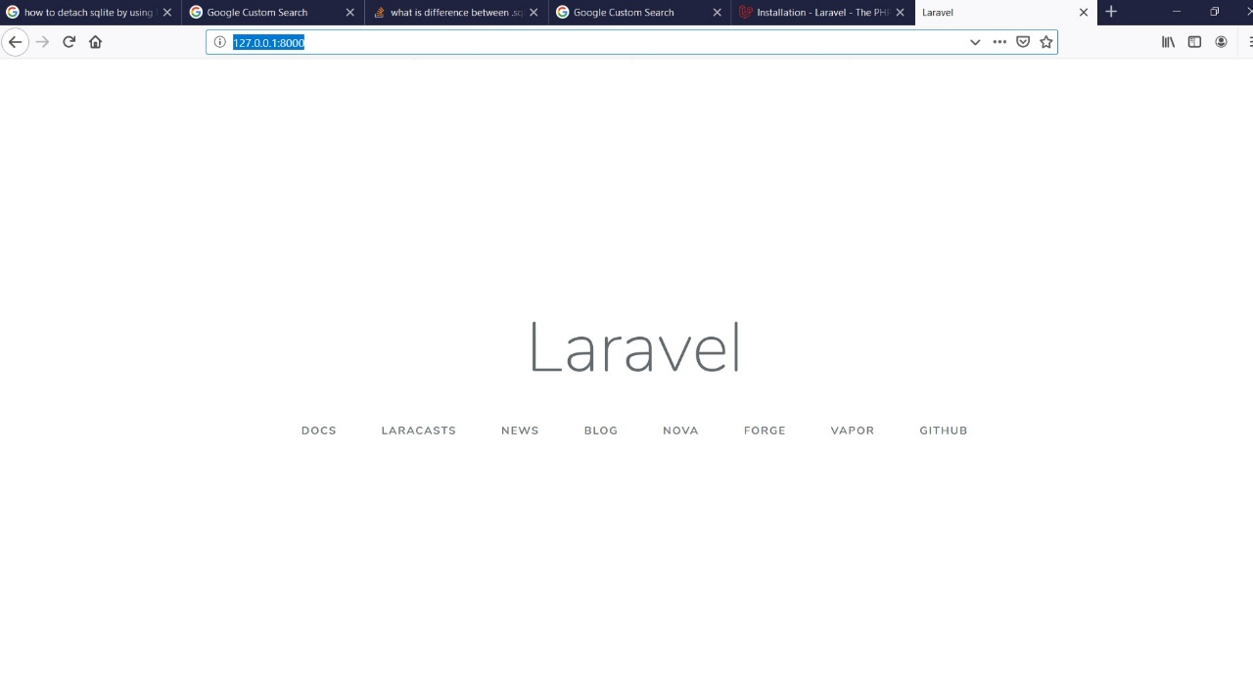

1. And then final step is using the Burmese Power from login

